Denver Seminary User Guide
- A computer

- Access to EBSCOhost (through the Carey S. Thomas Library’s website)

What You Will Need

The Steps
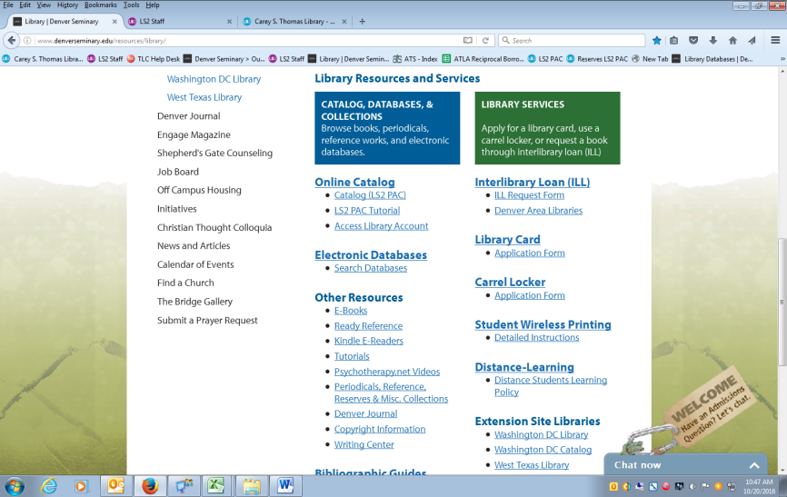
- EBSCOhost can be accessed through the Carey S. Thomas Library’s website, http://www.denverseminary.edu/resources/library/. Once you access that site, scroll down and click on the “Search Databases” link under “Electronic Databases,” as shown below.

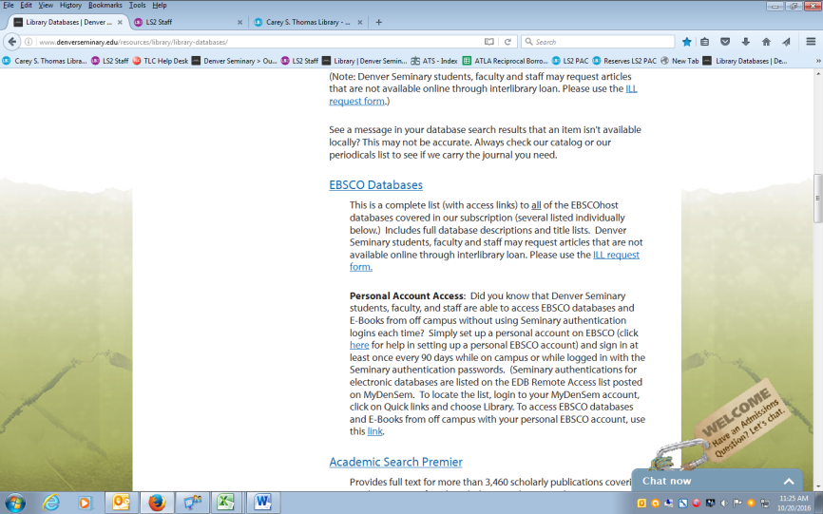
- Once you click on that link, you will be directed to the “Library Databases” page. Here, you will want to scroll down and click on “EBSCO Databases.” (If doing this from home, you will need to enter your MyDenSem credentials to log in.)

- Once you are logged in to EBSCOhost, you will need to select which databases you want to search by clicking on the select button(s) to the left of the desired entry/entries and then “Continue.” If unsure about which databases you want to search, simply click “Select all” and then “Continue” to search all databases. Otherwise, brief descriptions under each database entry can help you decide.

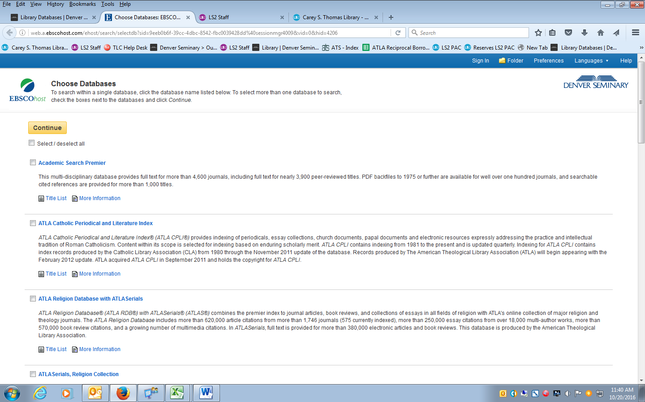

- This will take you to the search page. Here, you can run an advanced or basic search of journal or magazine articles, etc., by typing a key word, name, or phrase (or title, if you know what you are looking for exactly) in one or more of the search boxes and then clicking “Search.” You can also refine your search by selecting a field (e.g., “AU Author,” “TI Title,” “SU Subject Terms,” “SO Source”) in the dropdown menu(s) to the right of the search box(es). For other tips, see “Search Basics” and “Advanced Search Features” at the end of this user guide.
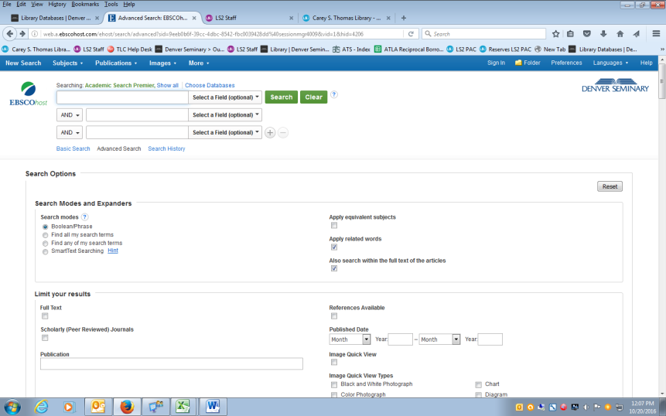

- After clicking “Search,” the search results page should appear. Here, you can view your search results, open detailed records, access PDFs and HTMLs of the desired article(s) (where accessible), or even refine your search. To open a detailed record, simply click on the blue title of an entry. To access a PDF or HTML, click on either “HTML Full Text” or “PDF Full Text.” And to refine your search, see “Advanced Search Features” below.

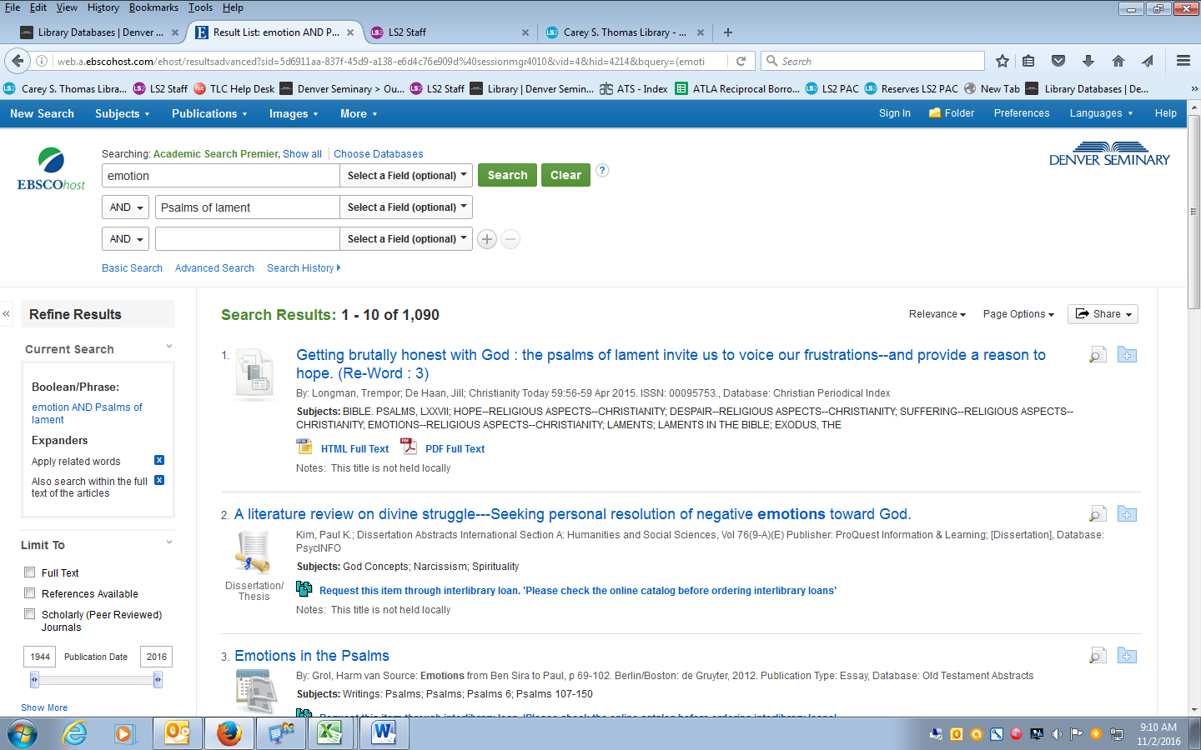
Note: Sometimes a PDF or HTML of an article is not available on EBSCOhost. In that case, the library may have a copy in either the bound or new periodicals collections. A list of our bound journals can be found on the book cart located next to the bound periodicals collection and at the public access computers station near the circulation desk. In the event the library does not hold that particular article, an Interlibrary Loan may be requested through our website.

- Once in the detailed record, you can view a wealth of bibliographic data, including an abstract, ISSN, digital object identifier, and much more. You can also access the HTML or PDF Full Text of an article (again, where accessible), print and/or email a record, and add the record to a folder. The “Find Similar Results” link, lastly, will allow you to access similar kinds of entries.
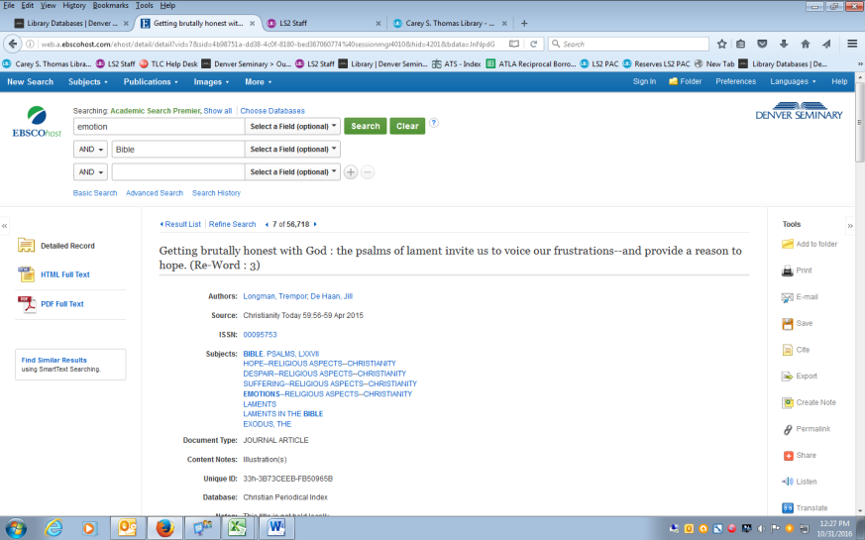

Search Basics
You can also refine your search by using Boolean Operators, Wildcards, and Truncation.
- Boolean Operators: “And,” “Or,” or “Not” combine terms to narrow or broaden results.
- Wildcard #: The “#” replaces any extra characters that may appear in alternative spellings. For example, “colo#r” finds both “color” and “colour.”
- Wildcard ?: The “?” replaces one character for any others; for example, “ne?t” finds “neat,” “nest,” and “next,” but will not find “net.”
- Truncation (*): The “*” replaces any number of characters and will find all forms of a word root. For example, “therap*” finds “therapy,” “therapies,” “therapist,” “therapists,” “therapeutic,” “therapeutically,” etc.

Advanced Search Features
A number of more advanced search features can help you limit or expand your results. These can be found on the left-hand side of the search results page (under “Refine Results”). For example, you can limit a search to:
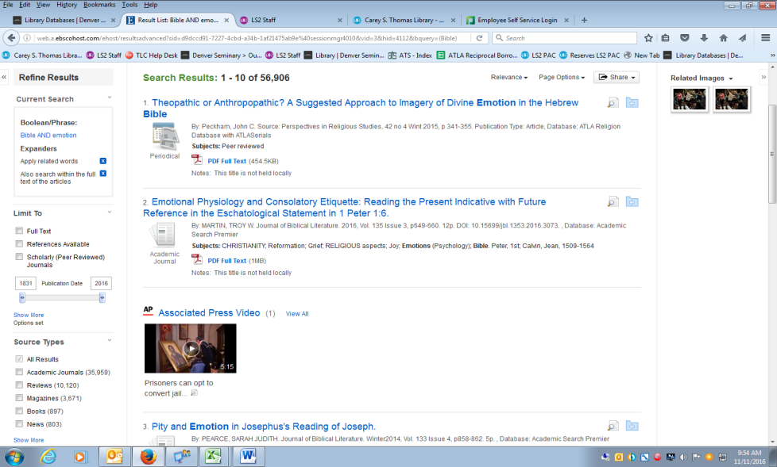
- Full Text
- References Available
- Scholarly Peer Reviewed Journals
- Publication Date
- Source Types (Academic Journals, Reviews, Magazines, Books, News, etc.)
- Subject
- Publisher
- Database

